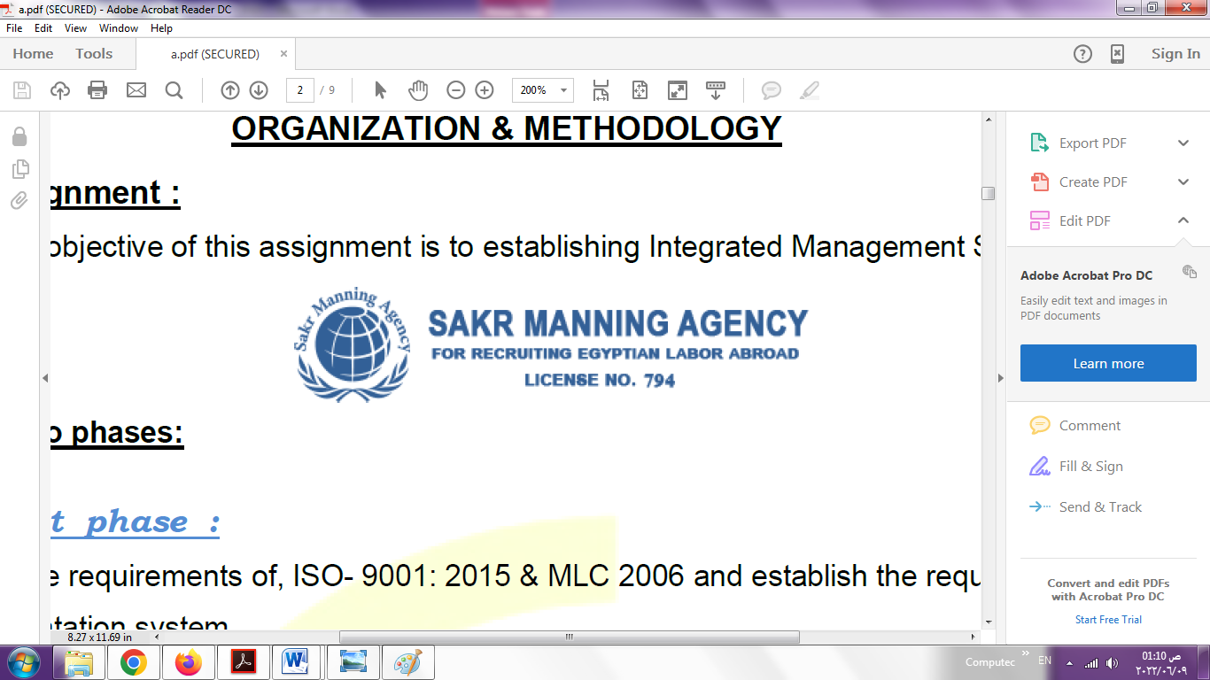 | SAKR MANNING AGENCY  FOR RECRUITING EGYPTIAN LABOR ABROAD | Issue Date | 15.05.2022
 |  | Revision Date | 27.05.2023
 | Crewing Management Manual  Seafarer Employment Application | Revision | 1.2
 |  | Page | 3
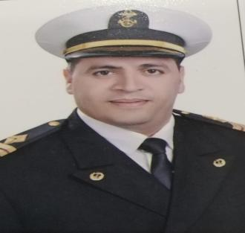
Application For Position as | 3rd marine eng
Register Code. | EO-3.088
Other Position (If Any)
Register Date | 31/08/2023
Last up Date Data
Expected Salary

1. PERSONAL DETAILS
Full Name |  | Amer Mohamed magdy Hassan khodir
Date Of Birth |  | 2\2\1987 |  |  |  |  |  |  | Place Of Birth |  |  |  |  |  |  |  | damietta
Nationality |  | egyptian |  |  |  |  |  |  | Marital Status |  |  |  |  |  |  |  | Single ☐ |  |  |  |  |  |  |  | Married ***☐
Height (Cm) |  | 165 |  |  |  |  |  |  | Overall Size |  |  |  |  |  |  |  | 58 |  |  |  |  | Shirt Size |  |  |  |  |  | xl
Weight (Kg) |  | 85 |  |  |  |  |  |  | Trouser Size |  |  |  |  |  |  |  | 4 |  |  |  |  | Shoes Size |  |  |  |  |  | 43
2. EDUCATION
College / School |  | Academy
Marline Test |  | Issued Date |  |  |  |  | Result % |  |  |  | Issued By (Authority) |  |  |  |  |  |  |  |  |  | Issued At
English Language |  | Fluent ☐ |  |  |  |  |  | Good \\☐ |  |  |  |  | Average ☐ |  |  |  |  |  |  |  | Poor ☐
……… Language  ( ) |  | Fluent ☐ |  |  |  |  |  | Good \\☐ |  |  |  |  | Average ☐ |  |  |  |  |  |  |  | Poor ☐
3. CONTACT DETAILS
Home Address / City |  |  | damietta
E-Mail |  |  | Amerkhodir2020@gmail.com |  |  |  |  |  |  | Mobile / Tel |  |  |  |  |  | 01272434422

4. TRAVEL DOCUMENTS
Type |  | Document No. |  |  |  | ISS. Date |  |  | Exp. Date |  |  |  |  | ISS. By (Authority) |  |  |  |  |  |  |  |  |  | Place of Issue
Passport |  | A27108801 |  |  |  | 23\08\2020 |  |  | 22\08\2027 |  |  |  |  | Egyptian Authority |  |  |  |  |  |  |  |  |  | damietta
Seaman Book |  | 214466 |  |  |  | 30\07\2023 |  |  | 29\07\2028 |  |  |  |  | EAMS |  |  |  |  |  |  |  |  |  | Alex.
Other Seaman Book |  | Cy327997 |  |  |  | 21\04\2021 |  |  | 20\04\2031 |  |  |  |  | Republic of cyprus |  |  |  |  |  |  |  |  |  | cyprus

5. PROFESSIONAL QUALIFICATION / CERTIFICATE OF COMPETENCY
Certificate Name |  |  |  |  | Number | Issue Date |  |  |  |  |  | Expiry Date |  |  |  |  |  | Issued By |  |  |  |  |  |  |  |  | Issued At
COC ( Rank) ……3rd eeng…….. |  |  |  |  | 5822 | 30\07\2023 |  |  |  |  |  | 27\07\2027 |  |  |  |  |  | EAMS |  |  |  |  |  |  |  |  | Alex.
GOC |  |  |  |  |  |  |  |  |  |  |  |  |  |  |  |  |  | NTRA |  |  |  |  |  |  |  |  | Cairo
D.P. INDUCTION
D.P. ADVANCED
D.P. OPERATOR (UNLIMITED)
6. NEXT OF KIN
Full Name | Ahmed Mohamed magdy khodir |  |  |  |  |  |  |  |  |  |  |  |  |  | Relationship |  |  |  |  | brother
Address | damietta
Tel. No. | 01026437062 |  |  |  |  |  |  |  |  | Mobile |  |  | 01203682745
7. HEALTH CERTIFICATES & VACCINATIONS
Flag State |  |  |  | Number |  |  | Issue Date |  |  |  |  | Expiry Date |  |  |  |  |  |  | Issued By |  |  |  |  |  |  | Issued At
International Medical |  |  |  | 5822 |  |  |  |  |  |  |  |  |  |  |  |  |  |  | EAMS |  |  |  |  |  |  | Alex.
Yellow Fever |  |  |  |  |  |  |  |  |  |  |  |  |  |  |  |  |  |  | Ministry of Health
Cholera |  |  |  | 122 |  |  | 02\07\2008 |  |  |  |  |  |  |  |  |  |  |  | Ministry of Health
Covid-19 |  |  |  | Vaccination Name |  |  | First Dose |  |  |  |  | Second Dose |  |  |  |  |  |  | (Other Does or Remarks)

8. MARINE COURSES
Course Name | Number | Issue Date | Expiry Date | Issued By / At
Personal Survival Techniques
Proficiency In Personal Survival Techniques | 18129\23\eg | 13\06\2023 | 11\06\2028 | academy
Fire Prevention and Fire Fighting
Advanced Fire Prevention and Fire Fighting | 18102\23\eg | 13\06\2023 | 11\06\2028 | academy
Elementary First Aid | 18843\23\eg | 18\06\2023 | 14\06\2028 | academy
Medical Care Studies
Personal Safety and Social Responsibilities | 18799\23\eg | 18\06\2023 | 14\06\2028 | academy
Proficiency Of Security Awareness Training Seafarers | 18725\23\eg | 18\06\2023 | 14\06\2028 | academy
Proficiency as a ship Security officer ( PSSO )
Proficiency In Survival Craft & Rescue Boats | 18129\23\eg | 13\06\2023 | 11\06\2028 | academy
G.M.D.S.S
Communications
Advanced Communications
ECDIS Advanced Simulator (Management Level)
ECDIS Simulator (Operation Level)
Prevention and Combating of Marine Pollution | 31796\18\eg | 18\10\2018 |  | academy
Radar & ARPA Simulator and Search &rescue
ARPA Simulator and Search
Marine Radar and automatic Radar Plotting
Bridge resource Management (B.R.M)
Engine resource Management (E.R.M)
Navigational Watch keeping
Proficiency for Rating forming part of Navigational watch (II/4) |  |  |  | EAMS / Alex.
High voltage training – operation of ship (1000 Volt and More)
Passenger Safety Cargo Safety and Hull integrity | 11220\22\eg | 04\04\2022 | 15\03\2027 | academy
Crowd Management Training | 11180\22\eg | 04\04\2022 | 12\03\2027 | academy
Crisis Management and Human Behavior Training | 11200\22\eg | 04\04\2022 | 16\03\2027 | academy
Safety training for Personal Prov. Direct Passengers | 11161\22\eg | 04\04\2022 | 14\03\2027 | academy
Practical Ability to Prepare Meals and (MLC 2006)
Personal Hygiene and Envir. Protection (MLC 2006)
Safety and Health in the Provision Meals (MLC 2006)
Food Storage and inventory Control (MLC 2006)
Ships Cook Certificate (MLC 2006) |  |  |  | EAMS / Alex.
Abel Seafarer Deck
Proficiency for Abel Seafarer Deck ( II/5 ) |  |  |  | EAMS / Alex.
Engineering Watch keeping |  |  |  | EAMS / Alex.
Proficiency for Rating forming part of a watch in engine room
Abel Seafarer Engine
Proficiency for Abel Seafarer Engine ( III/5 ) |  |  |  | EAMS / Alex.
Electro Technical Rating
Proficiency for Electro Technical rating ( III/7 ) |  |  |  | EAMS / Alex.

 |  |  | COMPLETE SEA – SERVICE DETAILS
Name: |  |  |  |  |  |  |  |  |  |  |  |  |  |  |  | Rank: |  |  |  |  | Register Code:
Company Name |  |  |  |  |  | Rank | Vessel Name |  |  | Flag |  |  | Signed On |  |  |  |  | Signed Off |  |  | Period |  | Vessel Type |  |  |  | D.W.T. |  |  | Engine Type |  | BH |  |  |  | KW
Variety cruises |  |  |  |  |  | 3rd eng | Variety voyager |  |  | majuro |  |  | 17\04\2019 |  |  |  |  | 15\11\2019 |  |  |  |  | Passenger\cruise |  |  |  |  |  |  | 2 x caterpillar |  |  |  |  |  | 1379.5
Variety cruises |  |  |  |  |  | 3rd eng | Variety voyager |  |  | majuro |  |  | 20\01\2020 |  |  |  |  | 23\06\2020 |  |  |  |  | Passenger\cruise |  |  |  |  |  |  | 2 x caterpillar |  |  |  |  |  | 1379.5
Ships management |  |  |  |  |  | 3rd eng | F\B galaxy |  |  | limassol |  |  | 07\11\2020 |  |  |  |  | 12\06\2021 |  |  |  |  | Ro ro passenger ship |  |  |  |  |  |  | Sulzer\zl40 |  | 4x4200 |  |  |  | 12365
Variety cruises |  |  |  |  |  | 3rd eng | Variety voyager |  |  | majuro |  |  | 25\06\2021 |  |  |  |  | 22\02\2022 |  |  |  |  | Passenger\cruise |  |  |  |  |  |  | 2 x caterpillar |  |  |  |  |  | 1379.5
Variety cruises |  |  |  |  |  | 3rd eng | Variety voyager |  |  | majuro |  |  | 28\04\2022 |  |  |  |  | 26\10\2022 |  |  |  |  | Passenger\cruise |  |  |  |  |  |  | 2 x caterpillar |  |  |  |  |  | 1379.5
Variety cruises |  |  |  |  |  | 3rd eng | Pan orama |  |  | greek |  |  | 26\10\2022 |  |  |  |  | 08\05\2023 |  |  |  |  | Passenger-sailing cruiser |  |  |  |  |  |  | 2 x 650 hp caterpillar |  | 720 |  |  |  | 537
 |  | SPECIALISED EXPERIENCE
 |  | Name |  |  |  |  |  |  |  |  |  |  |  |  | Type |  |  |  |  | From |  |  |  | To |  |  |  | Comments
 |  | I declare that the information I have given is, to the best of my knowledge, true and complete. I also declare that the documents submitted are genuine, given and sign by persons whose names appear on them.
 |  |  |  |  |  |  |  |  |  |  |  |  |  |  |  |  |  |  | 03\08\2023 |  |  |  |  |  |  |  |  |  | Khodir amer
 |  |  |  |  |  |  |  |  |  |  |  |  |  |  |  |  |  |  |  |  |  | DATE |  |  |  |  |  |  |  | SIGNATURE

